Task 3 Report
Student Name: Jayakodige Lasith charuka perera
student id: 105106314

1. Introduction
This task involved developing two comprehensive Python functions for stock market data visualization and analysis. The primary objective was to create flexible visualization tools that can adapt to different time periods and provide meaningful insights into stock price behavior.
The two main functions developed are:
- Candlestick chart function – provides detailed OHLC (Open, High, Low, Close) price visualization with technical analysis features
- Boxplot chart function – analyzes MidPrice distribution patterns over configurable rolling time windows
Both functions incorporate the critical feature of adjustable time periods (n-days), allowing users to analyze data at different granularities from daily to multi-day aggregations.

2. Candlestick Chart Function

Purpose and Functionality
The candlestick chart function serves as a comprehensive tool for technical analysis of stock price movements. Candlestick charts are particularly valuable because they display four critical price points (Open, High, Low, Close) in a single visual element, making it easier to identify price patterns, trends, and market sentiment.

Key Features Explained:
Multi-day Aggregation: When n_days > 1, the function intelligently combines multiple trading days into single candlesticks. This aggregation follows specific rules:
- Open: Takes the opening price of the first day in the period
- High: Captures the highest price across all days in the period
- Low: Records the lowest price across all days in the period
- Close: Uses the closing price of the last day in the period
- Volume: Sums the total volume across all days
Moving Averages: The function overlays multiple moving averages (default: 3, 6, 9 days) which help identify:
- Short-term vs. long-term trends
- Potential support and resistance levels
- Crossover signals for trading decisions
Volume Integration: Volume bars are displayed below the price chart, providing insight into:
- Market participation levels
- Confirmation of price movements
- Potential reversal signals
- import pandas as pd
- import matplotlib.pyplot as plt
- import mplfinance as mpf

- # ----------------------------
- # Ensure Volume is int and index is datetime
- # ----------------------------
- prepared_data['Volume'] = prepared_data['Volume'].astype(int)
- prepared_data.index = pd.to_datetime(prepared_data.index)

- # ----------------------------
- # Function: Candlestick chart
- # ----------------------------
- def plot_candlestick(data, n_days=1, title="Candlestick Chart", mav=(3,6,9)):
- """
- Plots a candlestick chart for stock data.

- Parameters:
- - data: pd.DataFrame with columns ['Open', 'High', 'Low', 'Close', 'Volume']
- - n_days: int, number of trading days per candle (>=1)
- - title: str, chart title
- - mav: tuple of ints, moving averages to display
- """

- # Resample data if n_days > 1 (aggregate OHLCV)
- if n_days > 1:
- data_resampled = data.resample(f'{n_days}D').agg({
- 'Open': 'first',
- 'High': 'max',
- 'Low': 'min',
- 'Close': 'last',
- 'Volume': 'sum'
- }).dropna()
- else:
- data_resampled = data.copy()

- # Plot using mplfinance
- mpf.plot(
- data_resampled,
- type='candle', # candlestick chart
- mav=mav, # moving averages
- volume=True, # show volume bars
- title=title,
- style='yahoo', # predefined style
- ylabel='Price ($)',
- ylabel_lower='Volume'
- )

- # Candlestick chart with 3-day candles
- plot_candlestick(prepared_data, n_days=3, title="CBA.AX 3-Day Candlestick")

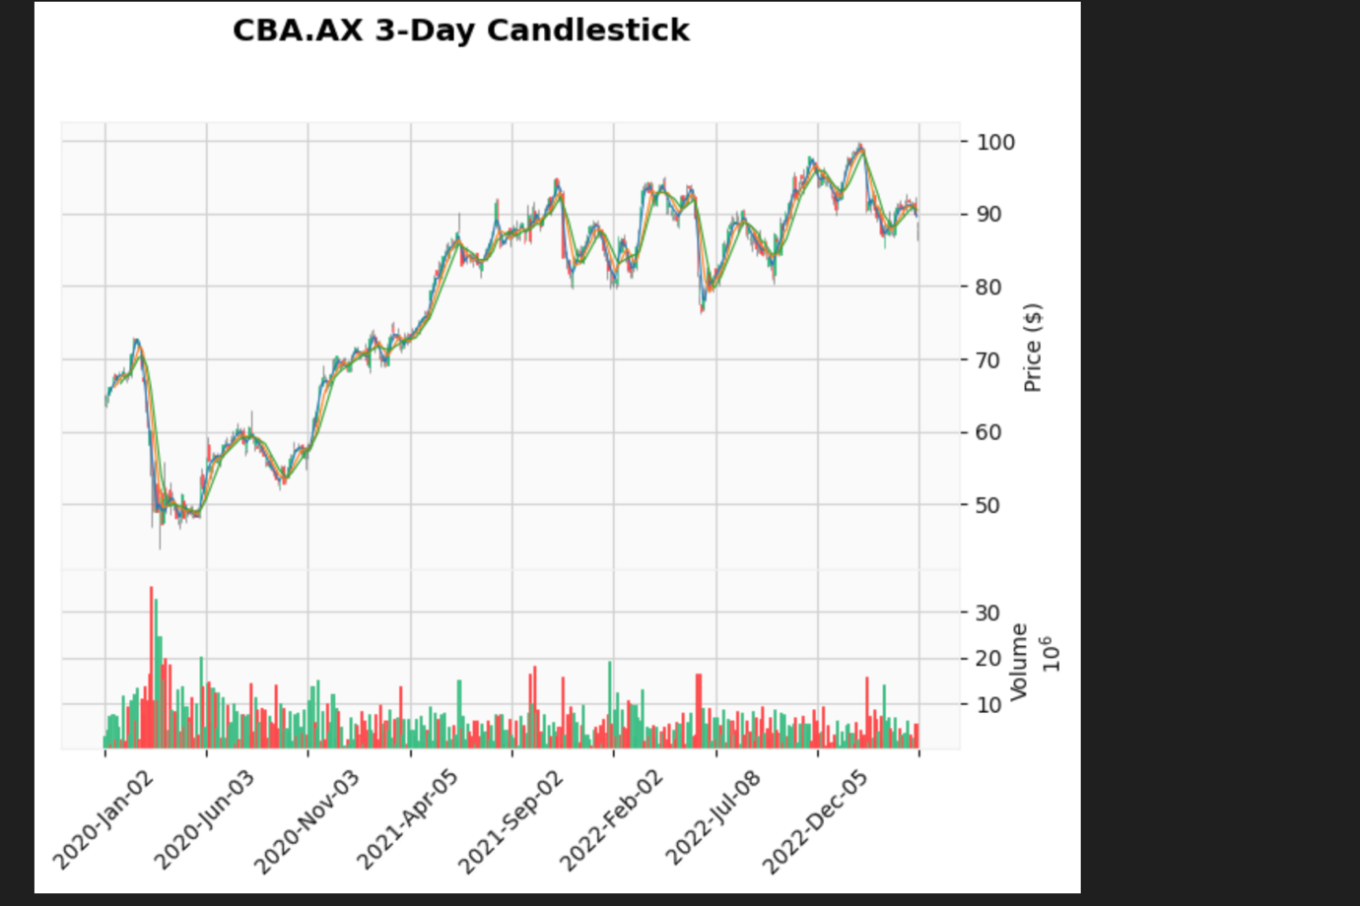

3. Interactive Boxplot Chart Function

Purpose and Advanced Analysis
The boxplot function provides statistical distribution analysis of stock prices over rolling time windows. This approach reveals patterns that traditional line charts cannot show, including:
- Price volatility changes over time
- Distribution skewness indicating market bias
- Outlier detection for unusual price movements
- Quartile analysis for risk assessment

Rolling Window Methodology:
The function creates overlapping time windows that slide through the dataset, with each window containing n consecutive trading days. This approach provides:
- Temporal continuity: Smooth transitions between periods
- Pattern recognition: Identification of volatility clusters
- Trend analysis: Changes in price distribution over time

Statistical Features Explained:
Box Components:
- Median line: Shows the middle value, indicating central tendency
- Box boundaries: Represent 25th and 75th percentiles (interquartile range)
- Whiskers: Extend to show the range of typical values
- Outliers: Individual points beyond normal range, indicating unusual price movements
Mean and Standard Deviation Display: The boxmean='sd' parameter adds:
- Mean marker: Average price for the period
- Standard deviation lines: Measure of price volatility

Interactive Features:
- Hover details: Precise price values and dates
- Zoom capability: Focus on specific time periods
- Pan functionality: Navigate through the entire dataset
- Export options: Save charts for reports and presentations
- import pandas as pd
- import plotly.graph_objects as go

- # Load prepared data
- prepared_data = pd.read_csv('prepared_data/CBA.AX_prepared.csv', index_col=0, parse_dates=True)
- prepared_data = prepared_data[pd.to_datetime(prepared_data.index, errors='coerce').notna()]
- prepared_data.index = pd.to_datetime(prepared_data.index)

- # Parameters
- n_days = 5 # rolling window size

- # Prepare rolling windows
- rolling_boxes = []
- window_labels = []

- for i in range(len(prepared_data) - n_days + 1):
- window_data = prepared_data['MidPrice'].iloc[i:i+n_days]
- rolling_boxes.append(window_data)
- window_labels.append(prepared_data.index[i + n_days - 1].strftime('%Y-%m-%d')) # label by last day

- # Create figure
- fig = go.Figure()

- # Add each rolling window as a box
- for label, values in zip(window_labels, rolling_boxes):
- fig.add_trace(go.Box(
- y=values,
- name=label,
- boxmean='sd', # show mean and std
- hovertemplate='Date: %{x}<br>Price: %{y}<extra></extra>'
- ))

- # Layout
- fig.update_layout(
- title=f'CBA.AX MidPrice Rolling Boxplot ({n_days}-day windows)',
- xaxis_title='End date of rolling window',
- yaxis_title='MidPrice ($)',
- template='plotly_white',
- height=600,
- boxmode='group'
- )

- fig.show()

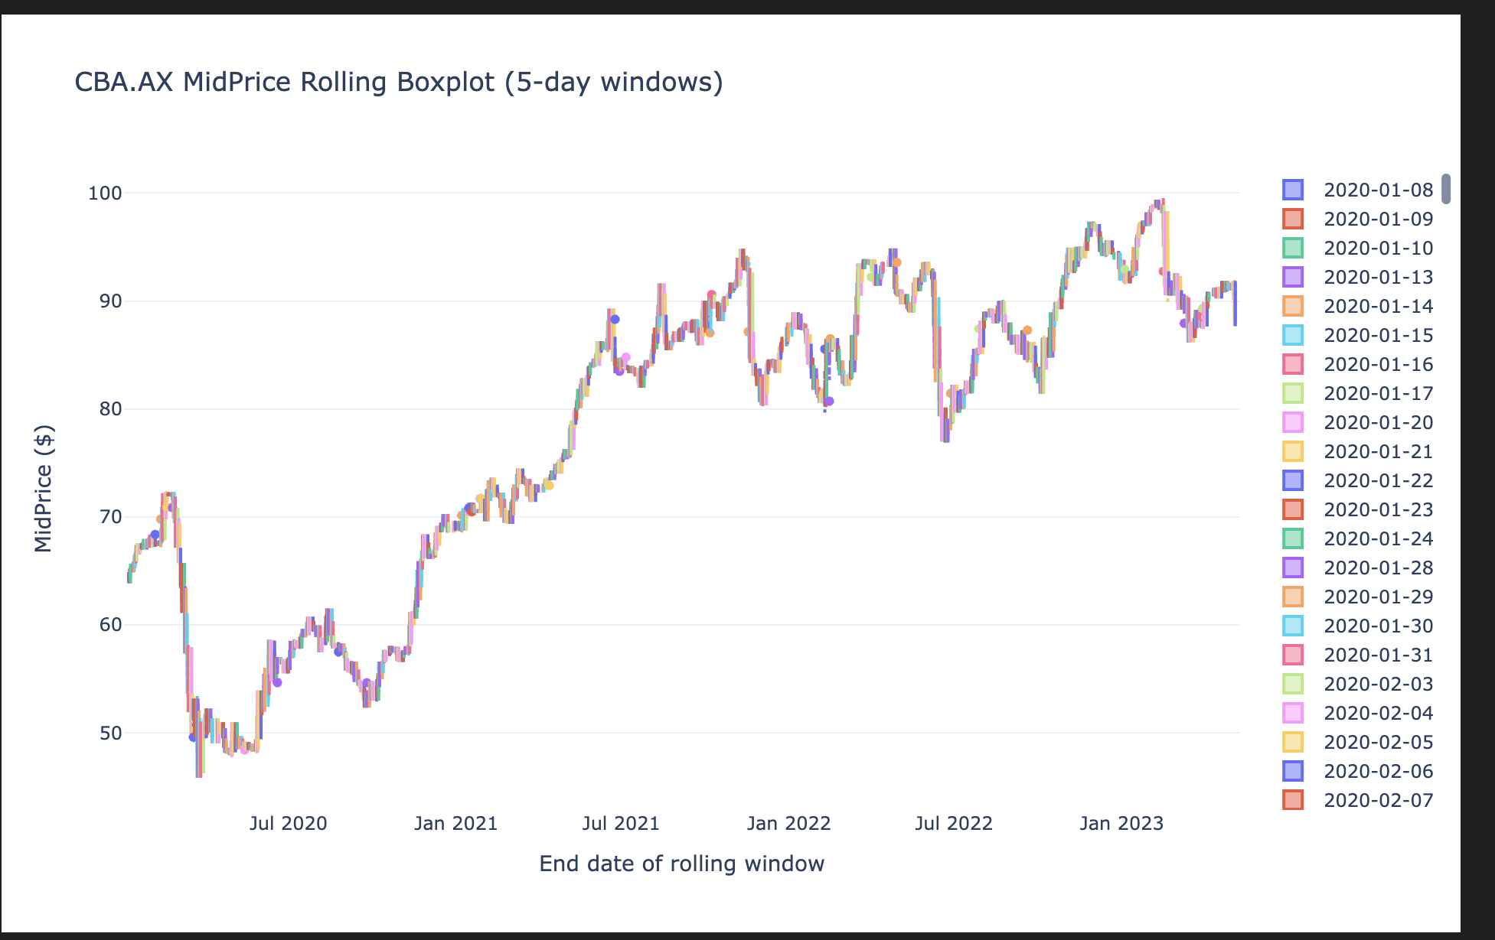

4. Technical Implementation Challenges & Solutions

Data Processing Challenges:
1. Datetime Index Parsing:
- Problem: CSV files often contain metadata rows (ticker symbols, headers) that interfere with datetime conversion
- Solution: Implemented data cleaning to filter non-datetime rows before applying pd.to_datetime()
- Technical approach: Used regex validation to identify and remove invalid datetime entries
2. Jupyter Notebook Integration:
- Problem: Interactive Plotly charts require specific dependencies and configuration in Jupyter environments
- Solution: Installed nbformat, plotly, and configured proper rendering settings
- Best practice: Added environment checks to ensure compatibility across different platforms
3. Time Series Aggregation Logic:
- Problem: Aggregating OHLC data requires different functions for each price component
- Solution: Implemented custom aggregation dictionary using pandas resample() method
- Performance optimization: Cached resampled data to avoid redundant calculations

Data Quality Considerations:
- Missing data handling: Forward-fill approach for gaps in trading days
- Volume validation: Ensured non-negative volume values
- Price consistency checks: Validated that High ≥ max(Open, Close) and Low ≤ min(Open, Close)

5. Practical Applications and Use Cases

For Traders and Analysts:
- Short-term analysis: Daily candlesticks for day trading decisions
- Medium-term trends: 3-5 day aggregation for swing trading
- Long-term patterns: Weekly/monthly candlesticks for position trading

For Risk Management:
- Volatility assessment: Boxplot analysis reveals changing risk levels
- Outlier detection: Identification of unusual price movements
- Distribution analysis: Understanding of price behavior patterns

For Academic Research:
- Market efficiency studies: Analysis of price distribution patterns
- Volatility clustering research: Rolling window statistical analysis
- Technical indicator validation: Moving average effectiveness studies

6. Conclusion and Future Enhancements
The developed functions provide robust, flexible tools for comprehensive stock market analysis. The candlestick function excels at revealing price action patterns and trends, while the boxplot function offers deep statistical insights into price distributions and volatility patterns.

Key Achievements:
- Flexibility: Configurable time periods for multi-scale analysis
- Interactivity: Modern web-based visualization with Plotly
- Professional quality: Publication-ready charts with proper styling
- Technical depth: Integration of multiple analytical approaches

Potential Future Enhancements:
- Additional technical indicators: RSI, MACD, Bollinger Bands
- Comparative analysis: Multi-stock overlay capabilities
- Real-time data integration: Live market data streaming
- Advanced statistics: Correlation analysis and regression features
These visualization tools demonstrate the power of combining traditional financial analysis techniques with modern Python data science capabilities, providing users with professional-grade analytical capabilities.

References:
- Mplfinance Documentation - Comprehensive candlestick charting
- Plotly Boxplot Guide - Interactive statistical visualization
- Pandas Resample Documentation - Time series aggregation methods

